STORING THE TOURNIQUET IN THE QUICK LAUNCH CONFIGURATION  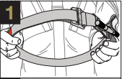  Pass the tip through the slit in the buckle. Pull (20 cm) of band through, fold it back and adhere the band to itself.  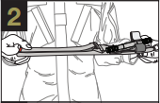  Flatten the loop formed by the band. Place the buckle in the middle of the flattened band.  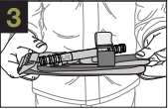  Fold the tourniquet in half placing the buckle at one end. The Tourniquet is now ready to place in your medical kit.  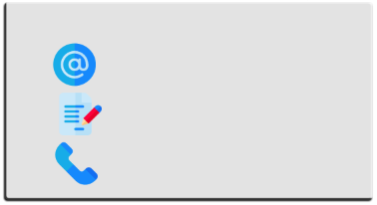  Contact us:  www.glia.org  github.com/GliaX  +972594433257 | 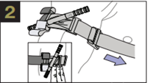  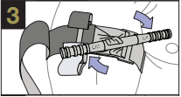  Pull the band tightly and fasten it back on itself all the way around the limb, but not over the rod clips. Band should be tight enough that tips of three (3) fingers cannot be slide between the band and the limb. If the tip of three (3) fingers slide under band, re-tighten and re-secure.  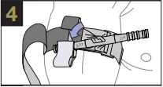  Twist the rod until bleeding has stopped.  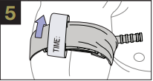  Secure the rod inside a clip to lock it in place. Check for bleeding and distal pulse. If bleeding is not controlled, or distal pulse is present, consider additional tightening or applying a second tourniquet above and side-by-side to the first. Reassess.  Route the band between the clips and over the rod. Secure rod and band with TIME strap. Record time of application. |   TOURNIQUET  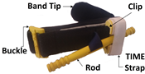  TOURNIQUET PARTS  INSTRUCTIONS FOR USE  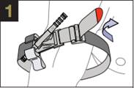  TWO-HANDED APPLICATION  Route the band around the limb, pass the tip through the slit of the buckle, and position the tourniquet (5-8 cm) above the bleeding site directly to the skin.  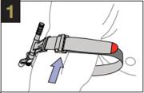  ONE-HANDED APPLICATION  Insert the injured limb through the loop in the band and position the tourniquet (5-8 cm) above the bleeding site directly to the skin.

